October | 2012

Toddler Activity Ideas
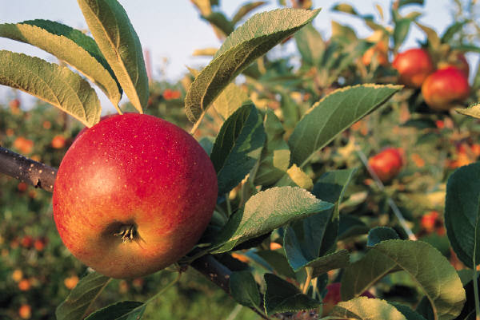
Sunday | Monday | Tuesday | Wednesday | Thursday | Friday | Saturday
 | 1 | 2 | 3 | 4 | 5 | 6
 |  |  |  | Apple stamping! Mail art to grandparents. | Apple rolling | bake an apple pie
7 | 8 | 9 | 10 | 11 | 12 | 13
 | Collect leaves and do leaf rubbings | Library: get leaf books! | Bleeding tissue paper leaves | Visit Anderson Farm | Farm animal coloring
14 | 15 | 16 | 17 | 18 | 19 | 20
On the farm! | Sing Old MacDonald with farm cards | Library: get farm books! | Play Heads and Tails game | Go to the park and play on the Tractor | Play with our farm playset.
21 | 22 | 23 | 24 | 25 | 26 | 27
Pumpkin Patch! | Fridge magnet pumpkins | Library: get pumpkin books! | Pumpkin paintings | Pumpkin pie play dough. | Paint on a pumpkin | Carve pumpkins!
28 | 29 | 30 | 31
Halloween Week | Decorate a candy bag | Library: Halloween books | Halloween!
Supplies:  Washable Paints  Magnetic sheets | Bleeding tissue paper  regular paper | pumpkins  flour  pumpkin pie spice | cinnamon  salt  cream of tartar  cooking oil | orange food coloring  paper bag with handles

